LAB #6
Efe Emir Cesur
Student ID #: 22608
Lab Section : A
1. Introduction
In this experiment, the primary objective is to design and implement a function generator capable of producing square, triangular, and sinusoidal waveforms. The laboratory sessions aim to combine fundamental electronic components, specifically RLC passives, operational amplifiers, and diodes, into system-level applications. To achieve these goals, the LM741 operational amplifier is utilized alongside standard laboratory equipment, including an oscilloscope, DC power supply, multimeters, and various standard-value resistors and capacitors. The final design must generate approximately 5 V square and triangular waves, an adjustable 0 V to 5 V sine wave, and operate within a tunable frequency range of 0.5 kHz to 10 kHz using +15 V and -15 V power supplies.
To fully comprehend the circuit behaviors observed in this lab, several fundamental theoretical concepts regarding the system's sub-blocks must be established:
Schmitt Trigger: The Schmitt trigger is a nonlinear, op-amp-based positive feedback circuit. In this function generator setup, it acts as a bistable multivibrator responsible for generating the initial square wave from which the other waveforms are derived.
Integrator: The integrator is a linear circuit built using an operational amplifier, a capacitor, and resistors. When the square wave from the Schmitt trigger is applied to its input, the integrator outputs a triangular wave. A feedback resistor is included in the design to provide finite gain at DC, which is necessary to prevent stability issues.
Triangle-to-Sine Converter: This nonlinear wave-shaping block consists of a network of resistors and diodes. It operates by clipping the incoming triangular waveform at specific input voltage levels. By carefully selecting resistor values to create distinct voltage break points, the diodes conduct at different stages, altering the slope of the signal to produce an approximately sinusoidal output waveform.
2. Pre-Lab Work
For the pre-lab work, bistable multivibrators, generation of square and triangular waveform using astable multivibrators and nonlinear waveform-shaping circuits are studied from textbook.
Also a function generator theoretically calculated and designed using LTSpice and simulated.
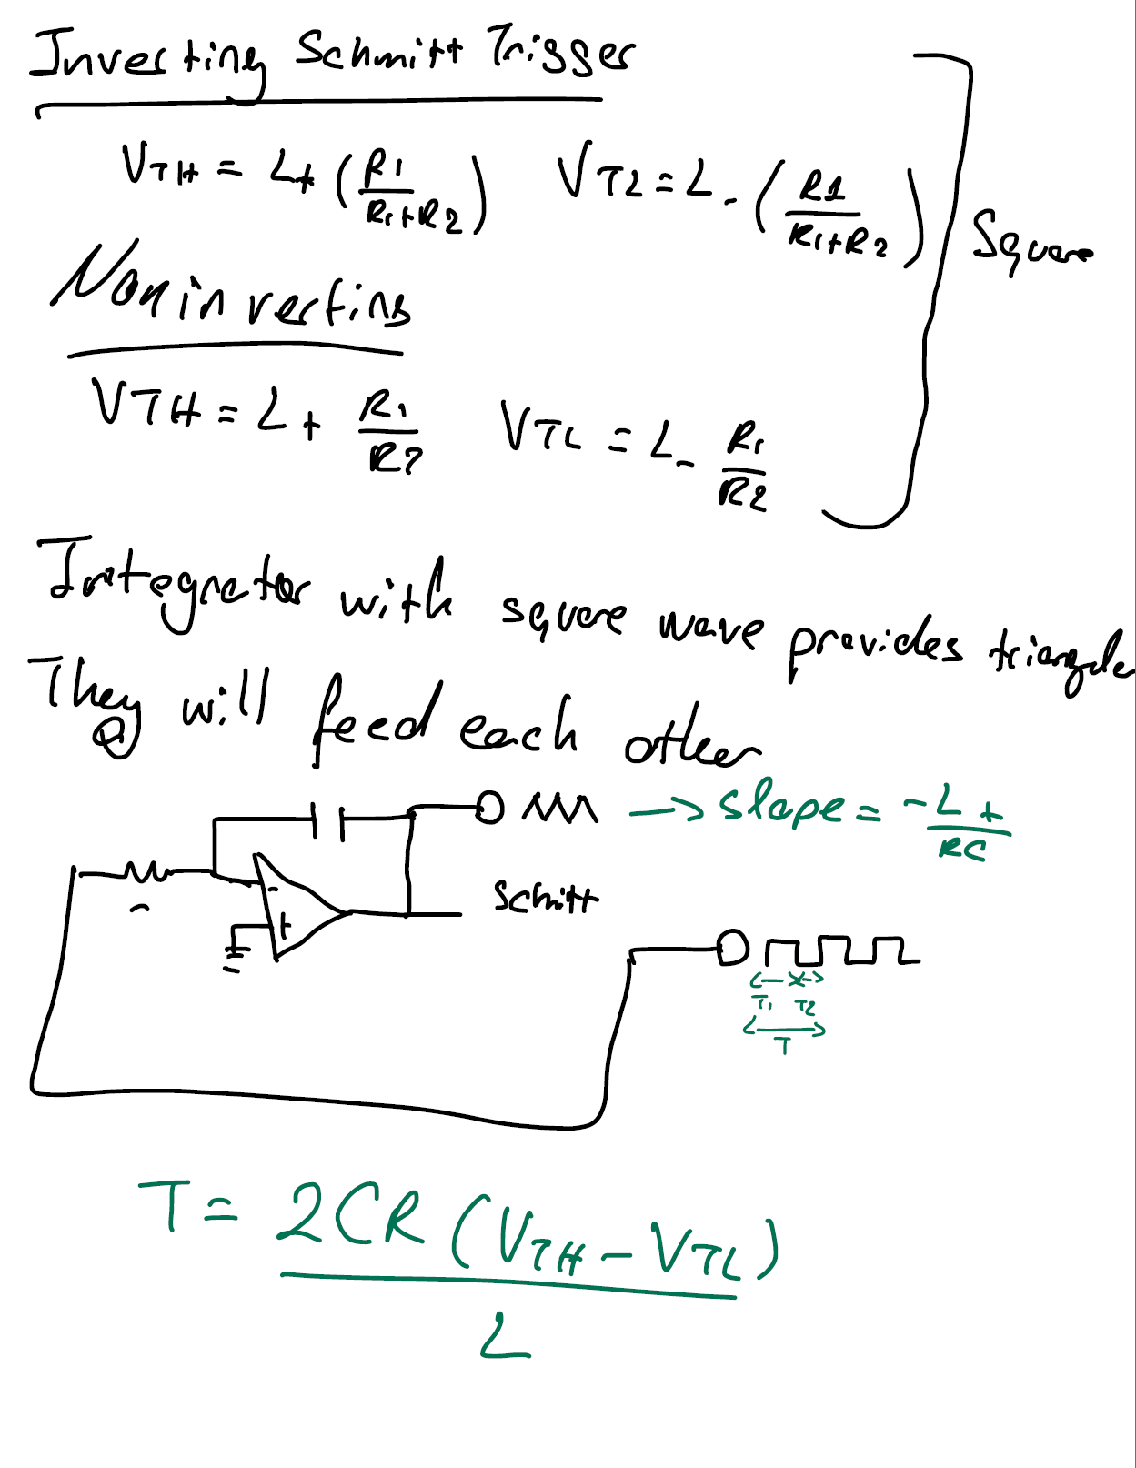
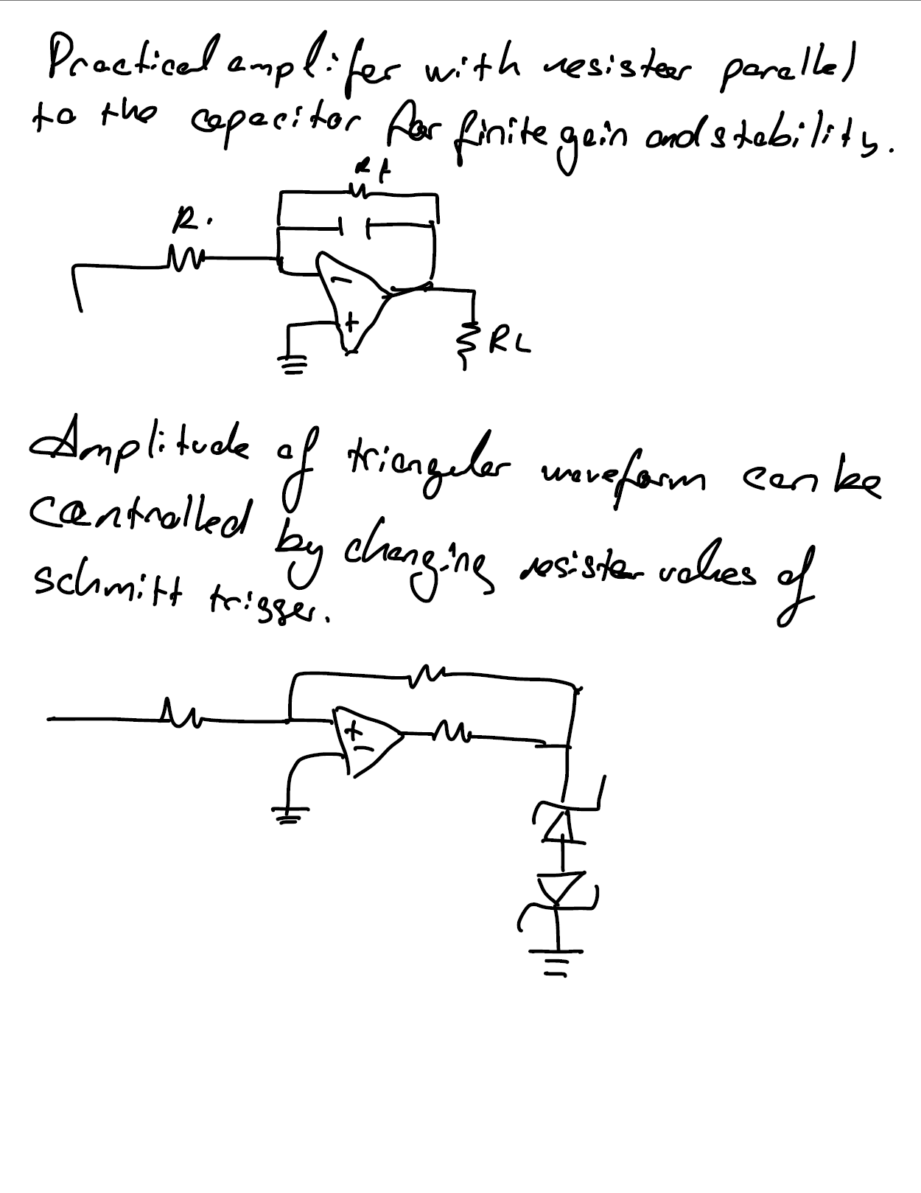
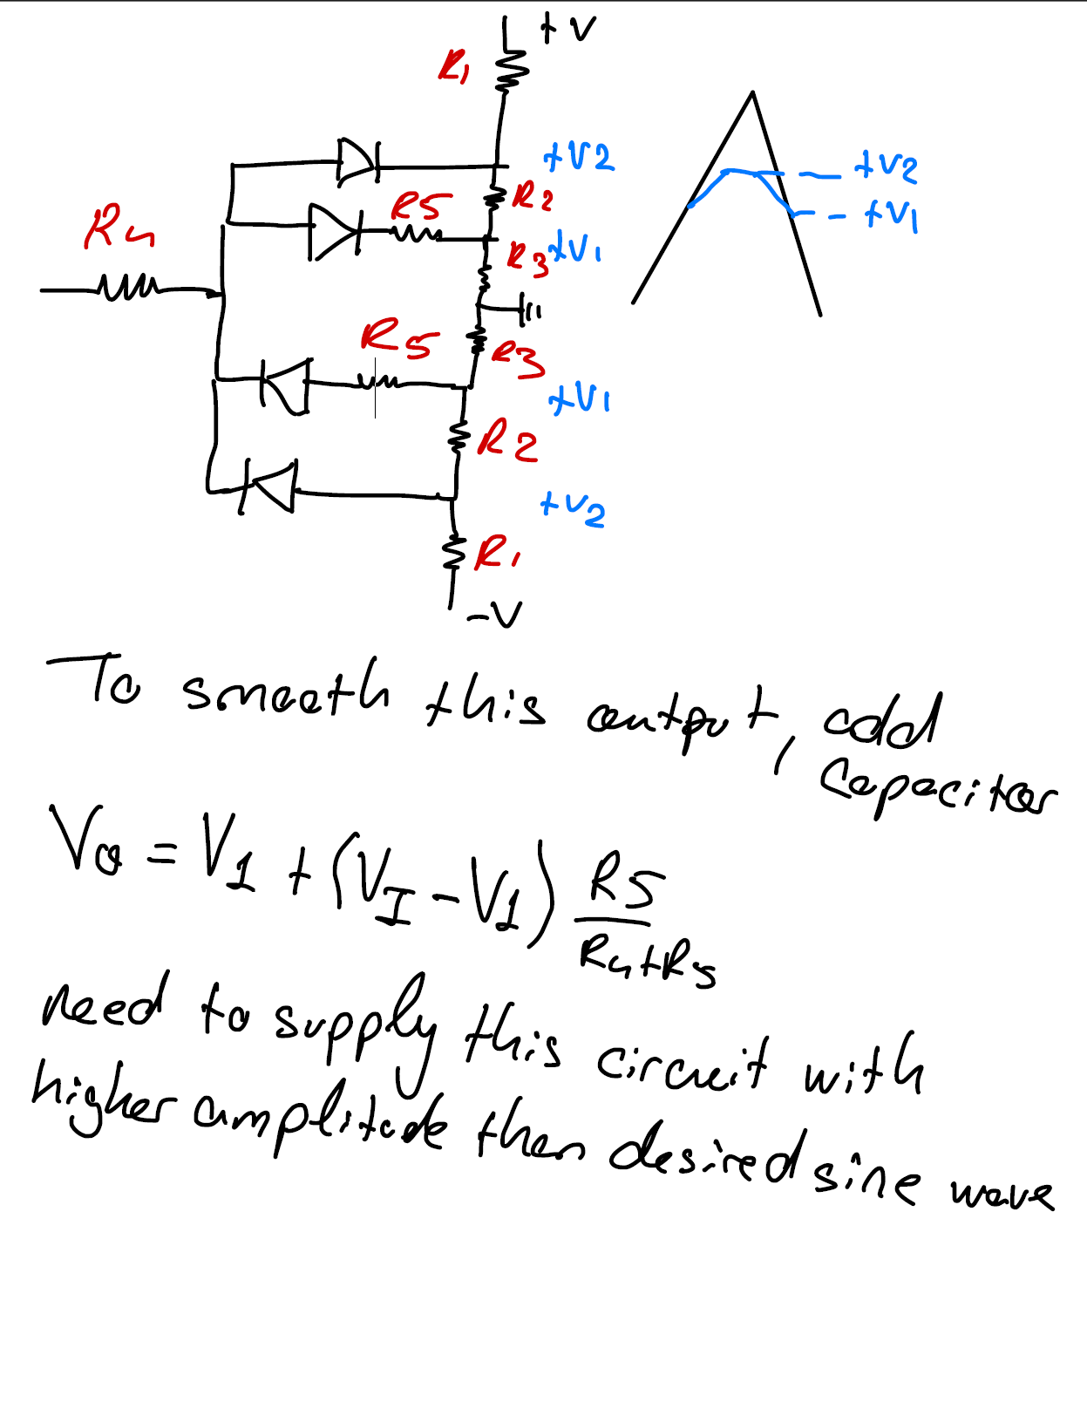
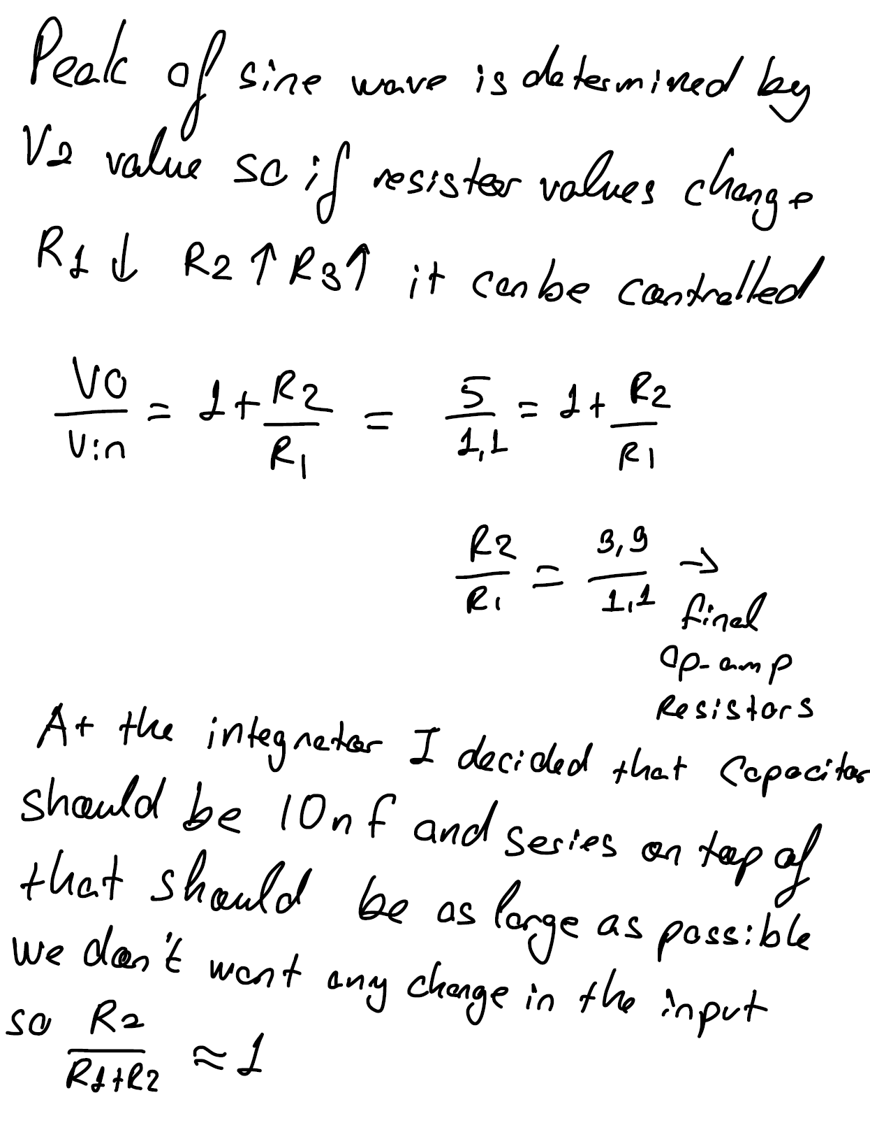
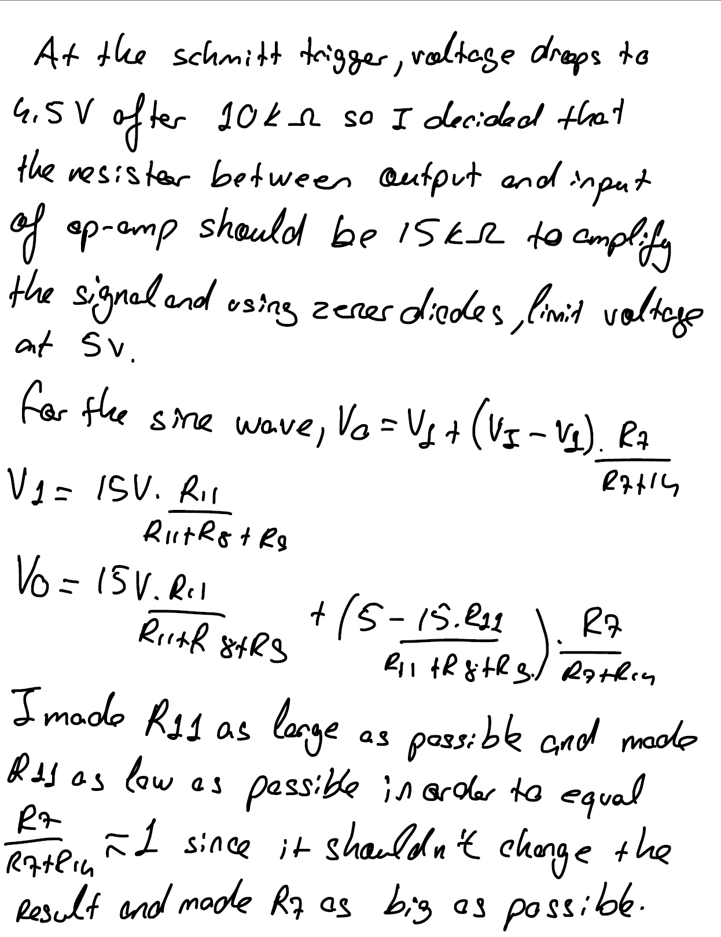
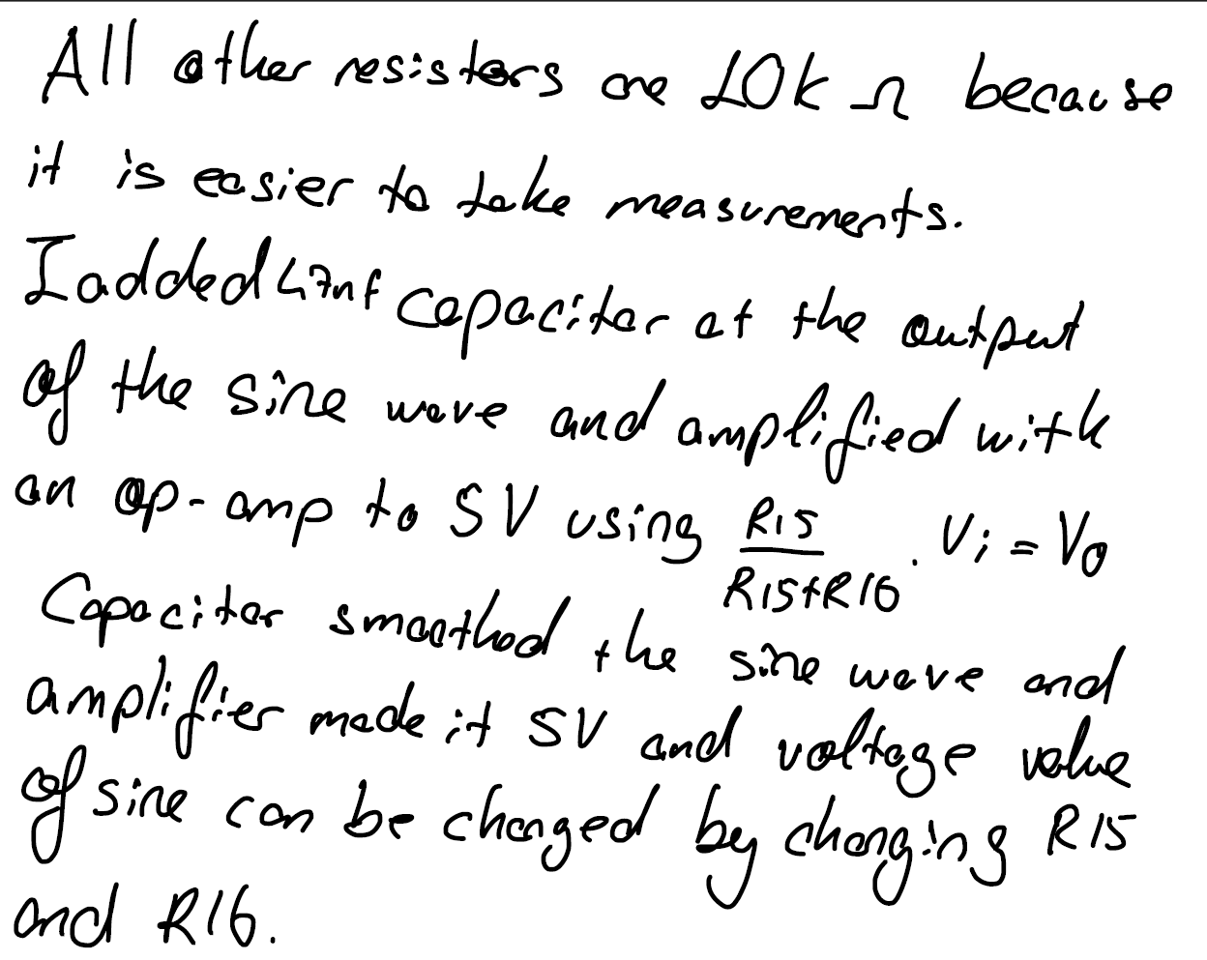
Figure 1: Simulation Results on LTSpice
Figure 2: Function generator circuit built on LTSpice
3. Data/Results
Part – 1 5V square wave at 0.5 kHz and 10 kHz
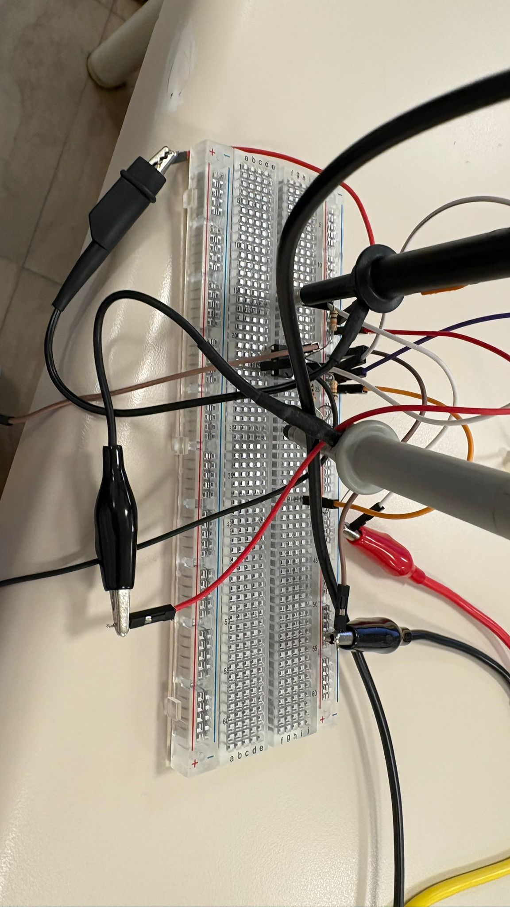
Figure 3: Schmitt Trigger built on Breadboard
Schmitt Trigger is built using an op-amp; 10k, 1k and 5k ohm resistances for generating square waves at different frequencies.
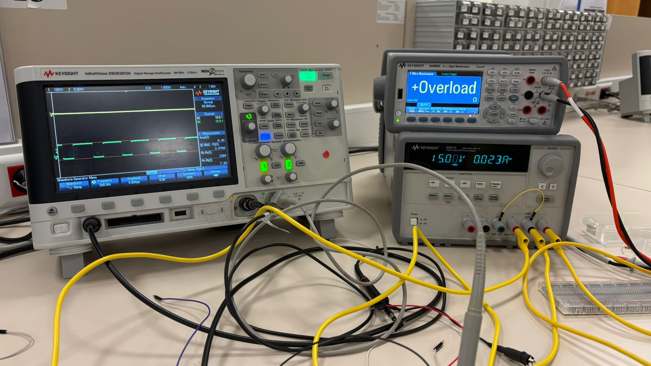
Figure 4: Measurements on Schmitt Trigger
Part – 2 5 V triangular wave at 0.5 kHz and 10 kHz
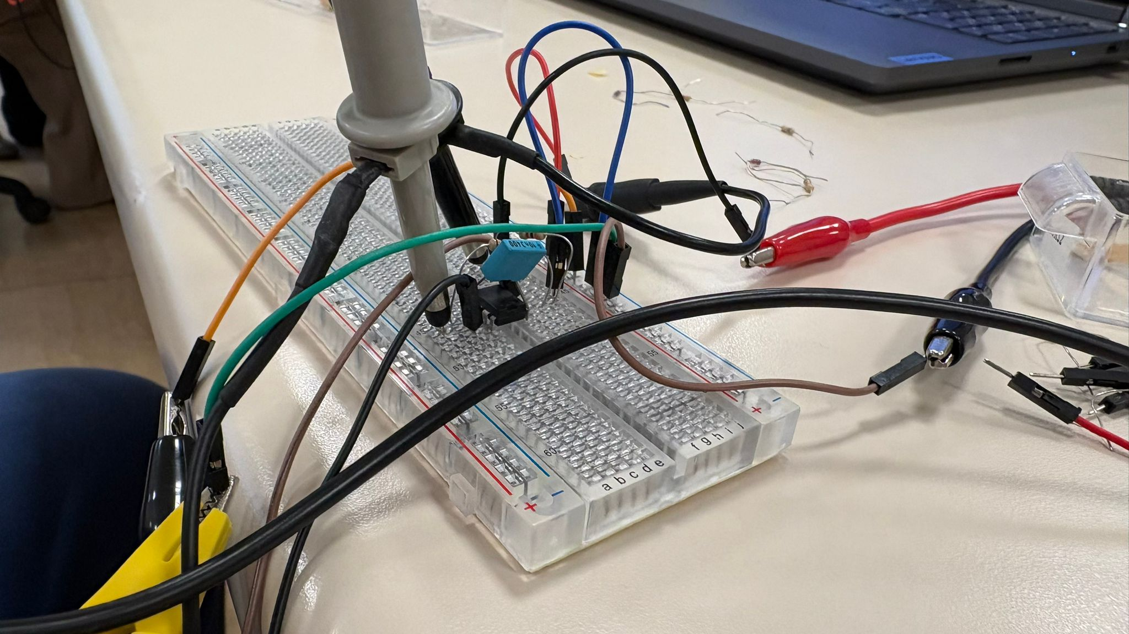
Figure 5: Integrator built on breadboard
Integrator is built using an op-amp; 2 10k and 1M resistances and a 10nF capacitor.
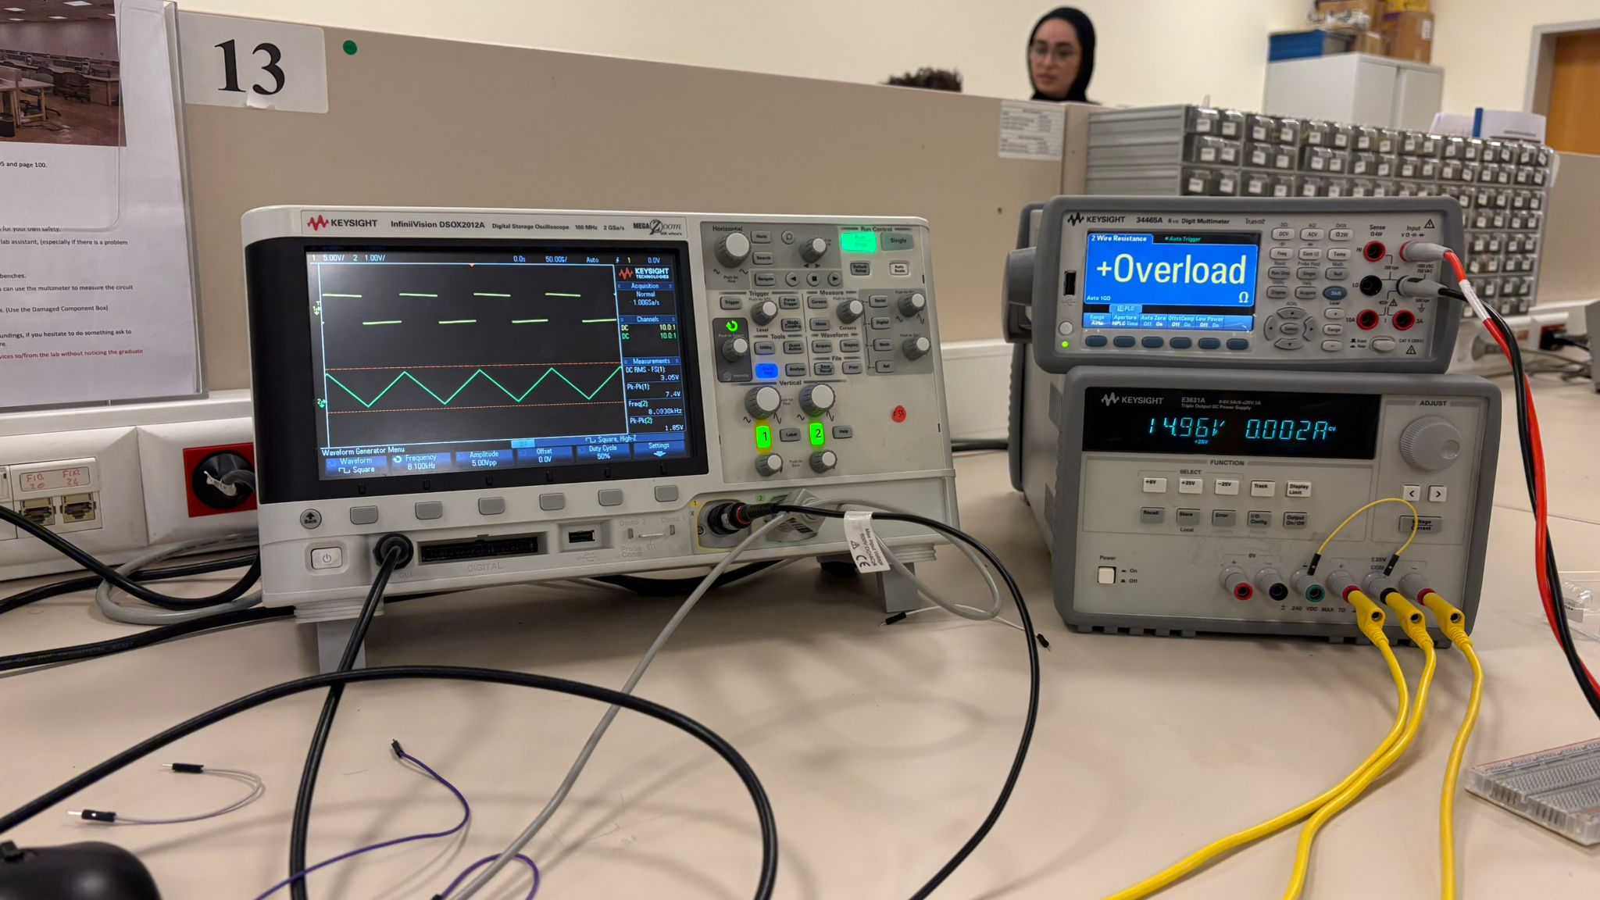
Figure 6: Measurements on Integrator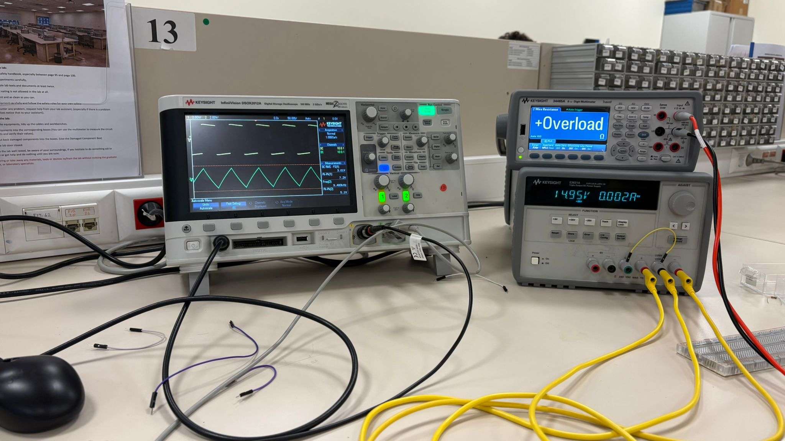
Figure 7: Integrator with zener diodes

Part – 3&4 5V and 10 V sinusoidal wave at 0.5 kHz and 10 kHz
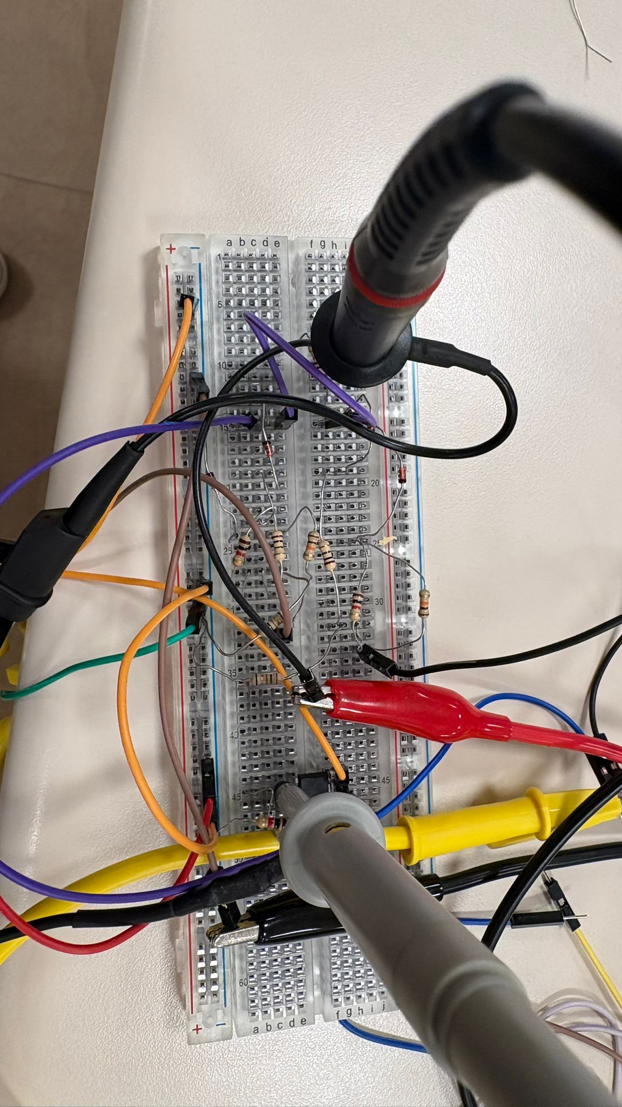
Figure 8: Triangular to Sine Converter circuit with an op-amp circuit for later amplification.
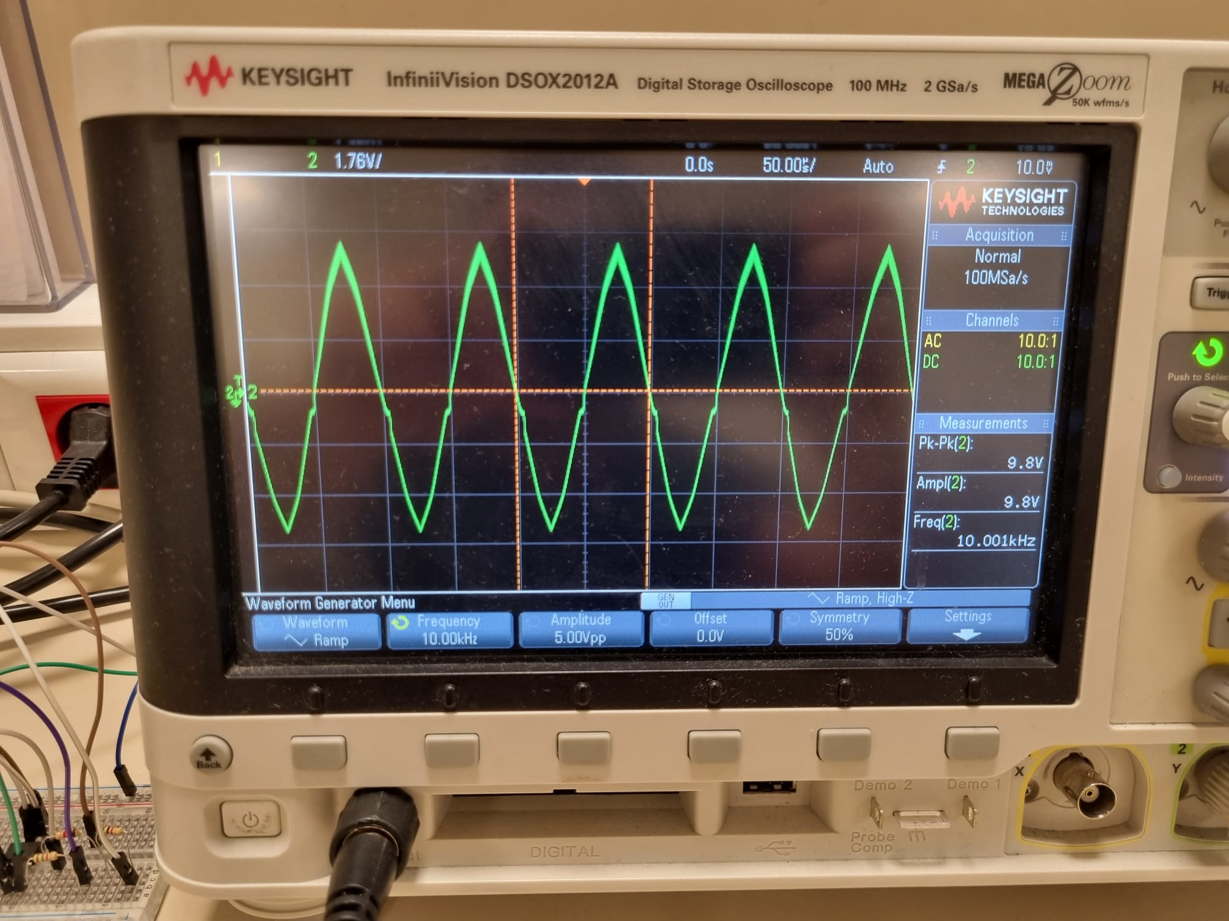
Figure 9: Measurements on Triangular to Sine Converter circuit

4. Discussion
The experimental results obtained from the implementation of the function generator demonstrate a correlation between theoretical designs, LTSpice simulations, and measurements. The system's operation relied on the sequential processing of signals through three primary sub-blocks: the Schmitt trigger, the integrator, and the triangle-to-sine wave converter.
The Schmitt trigger successfully generated a square wave by utilizing positive feedback to create triangular waves. The frequency of the system was controlled by the RC time constant of the integrator stage. Minor differances between the calculated and measured frequencies can be attributed to the tolerance of the components.
The integrator stage performed as expected, converting the square wave into a symmetrical triangular wave. The inclusion of the feedback resistor was critical for DC stability, preventing the op-amp from saturating due to integrated input offsets. Finally, the triangle-to-sine converter utilized a nonlinear diode-resistor network to approximate a sinusoidal output. The break points of the diodes, determined by the voltage divider network, effectively rounded the peaks of the triangular wave, validating the theoretical wave-shaping methodology.
5. Conclusion
In this experiment, a complete multi-waveform function generator was designed, simulated, and implemented. The lab work; integrated various electronic concepts, including positive feedback, linear integration, and nonlinear wave-shaping. The design specifications, output amplitude for square and triangular waves were achieved within acceptable margins of error.
The transition from LTSpice simulation to workbench implementation highlighted the importance of considering non-ideal component characteristics. Overall, the experiment made clear about the theoretical principles of bistable multivibrators and integrators, demonstrating how individual sub-blocks can be combined to create a complex, functional system-level application.

